0 level dfd for the system
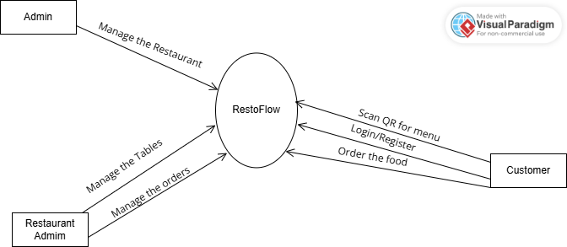ō
or
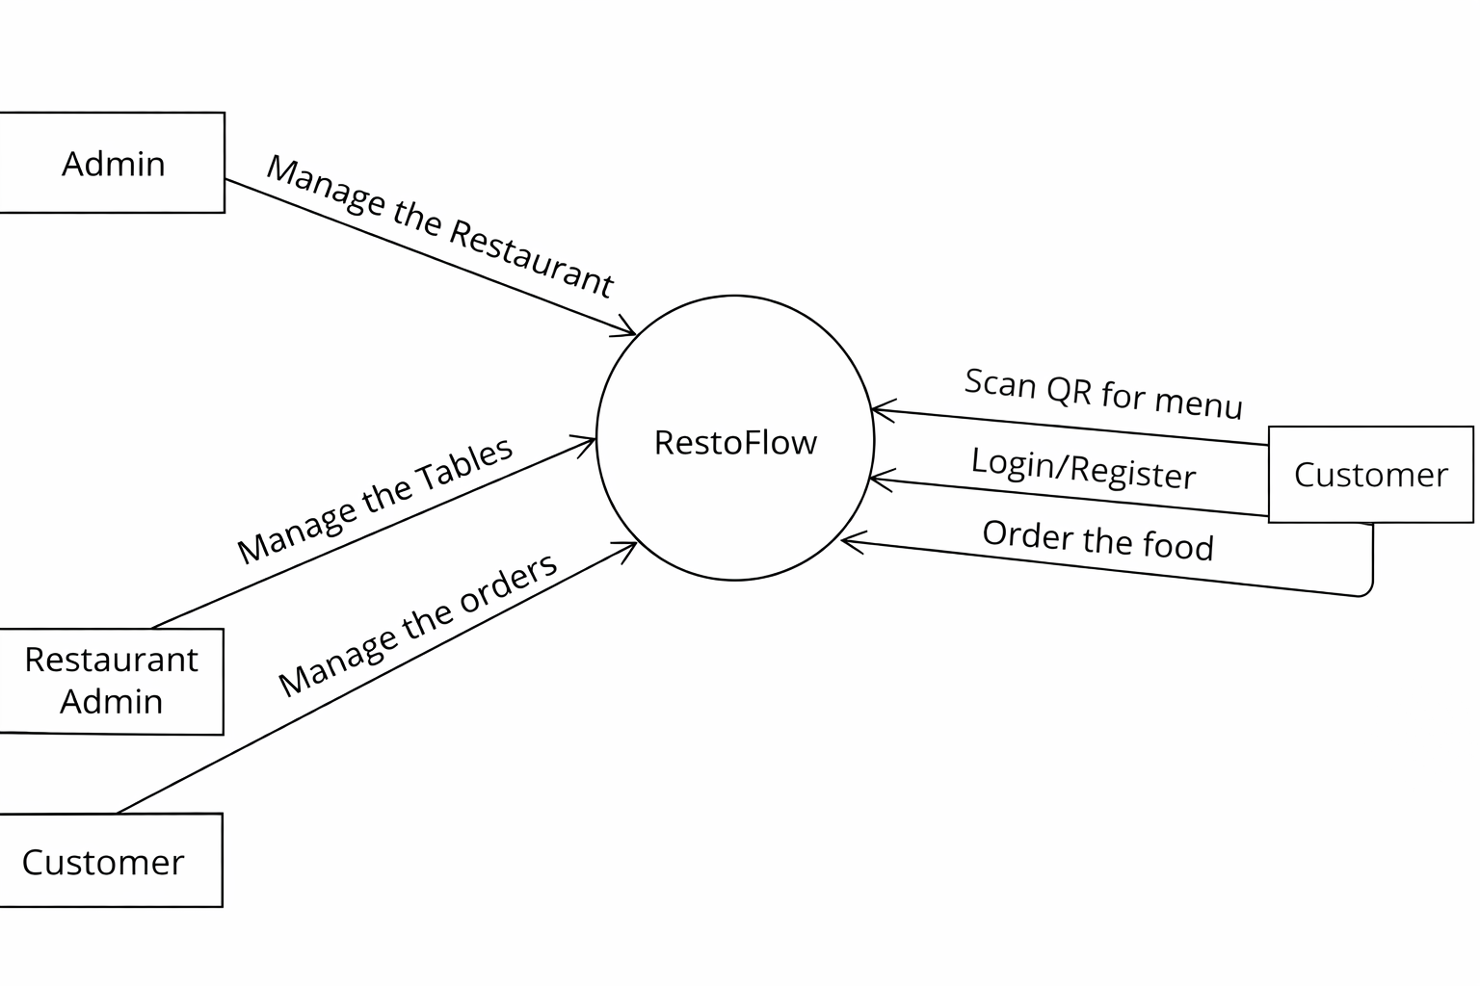

Level 1 dfd
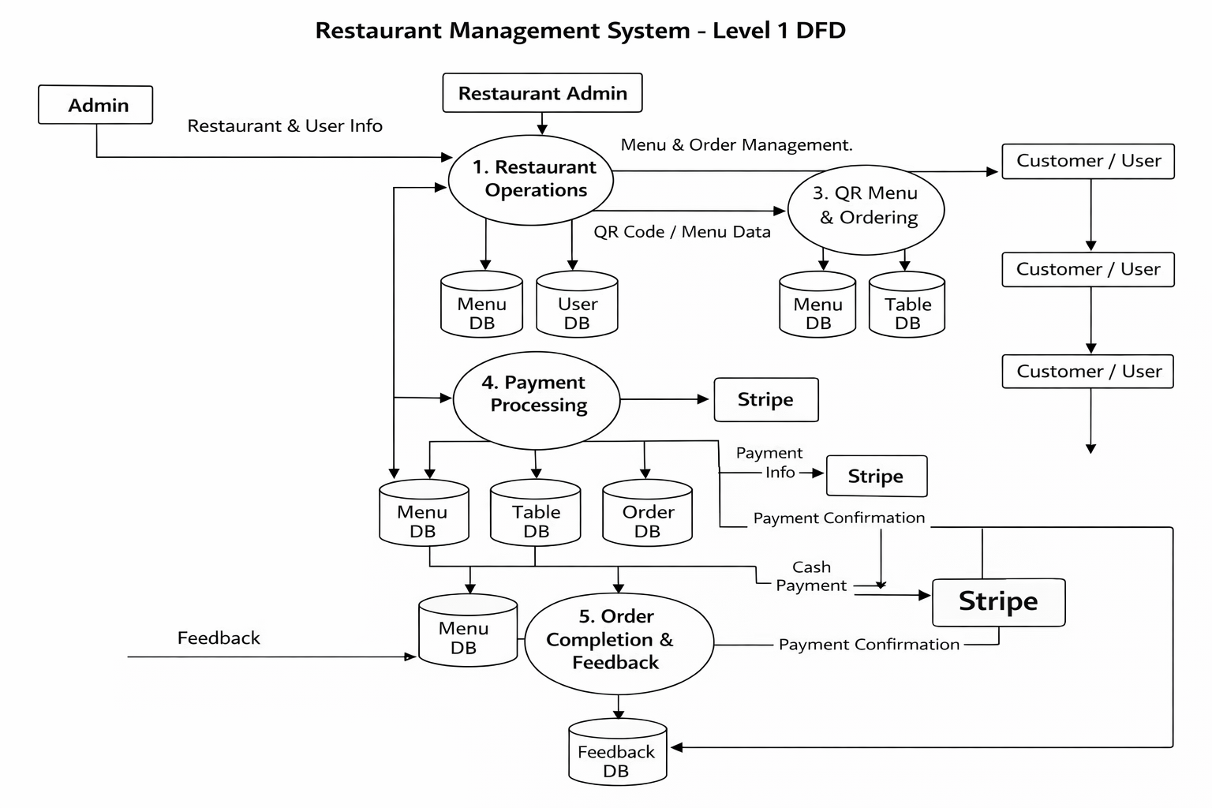

2 level food management
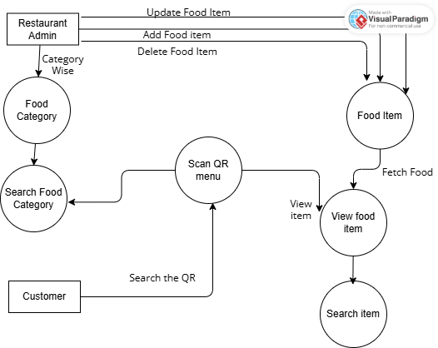
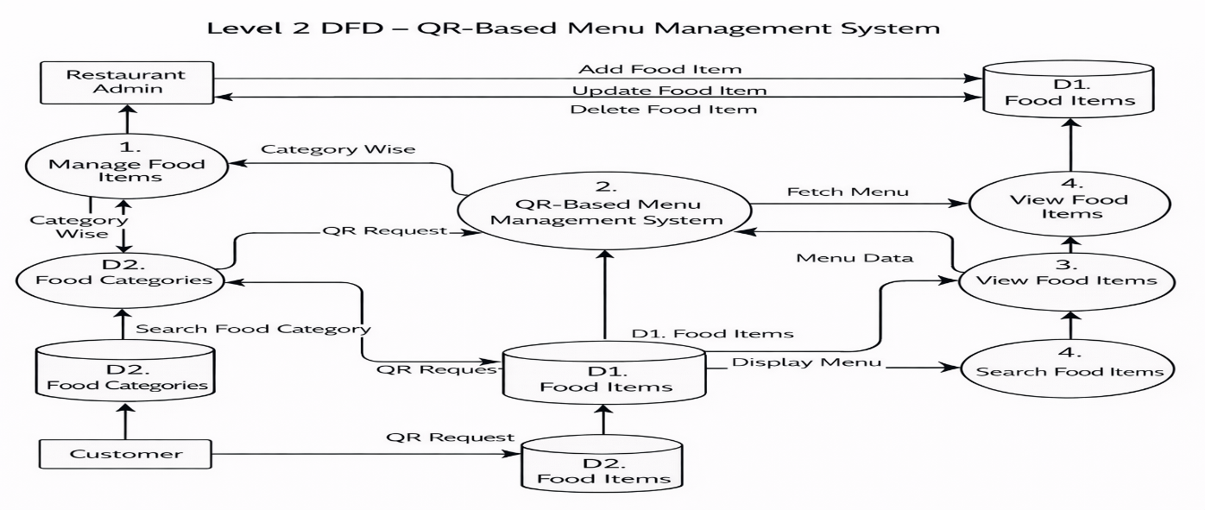
2 level user management
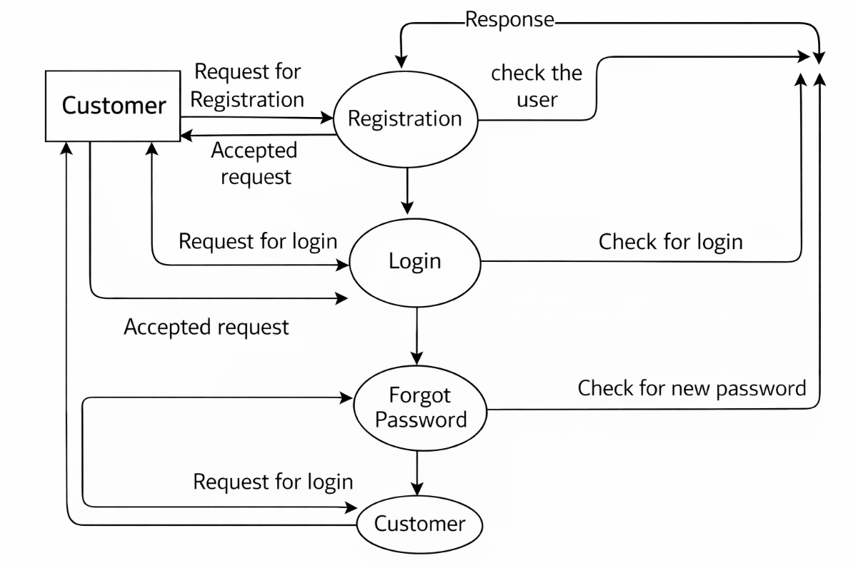
User
New to add 👆
2 level order management
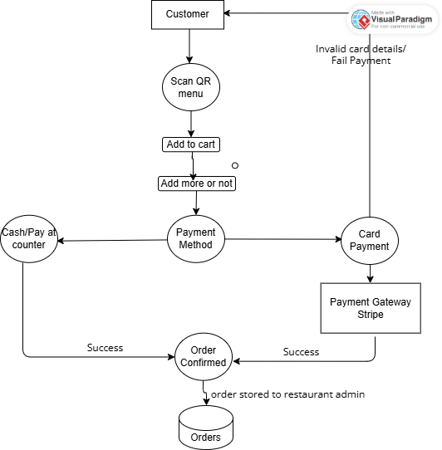
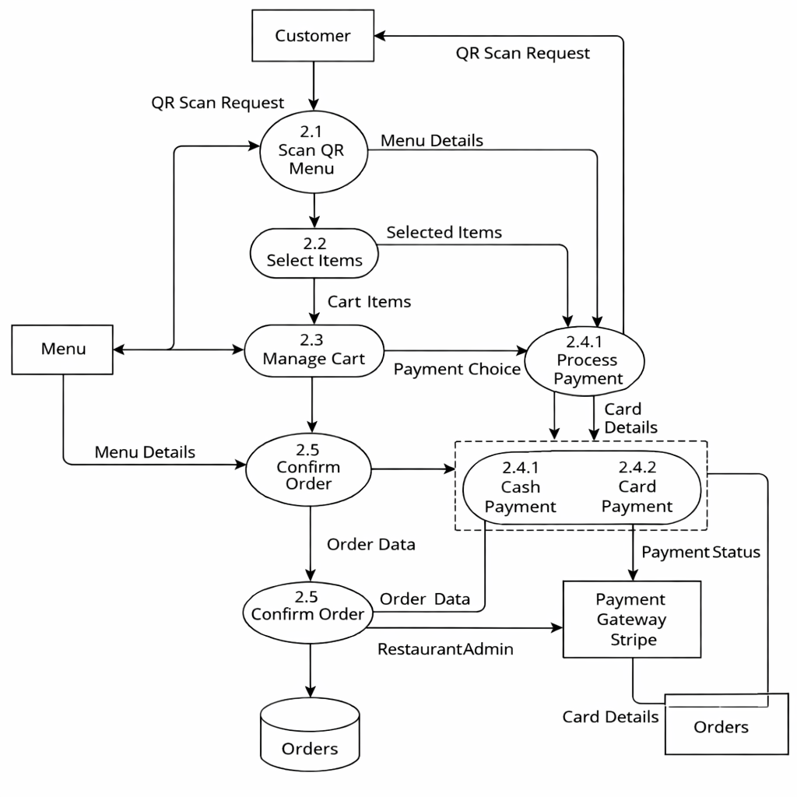
2 level for reservation
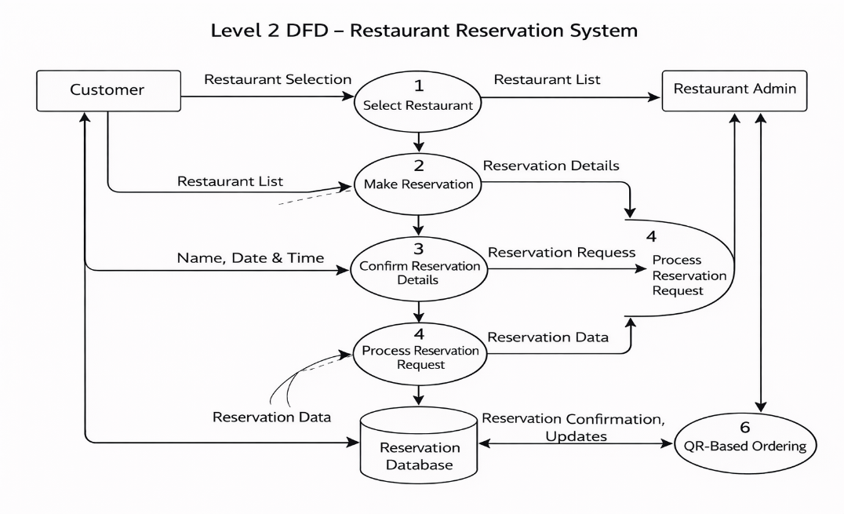
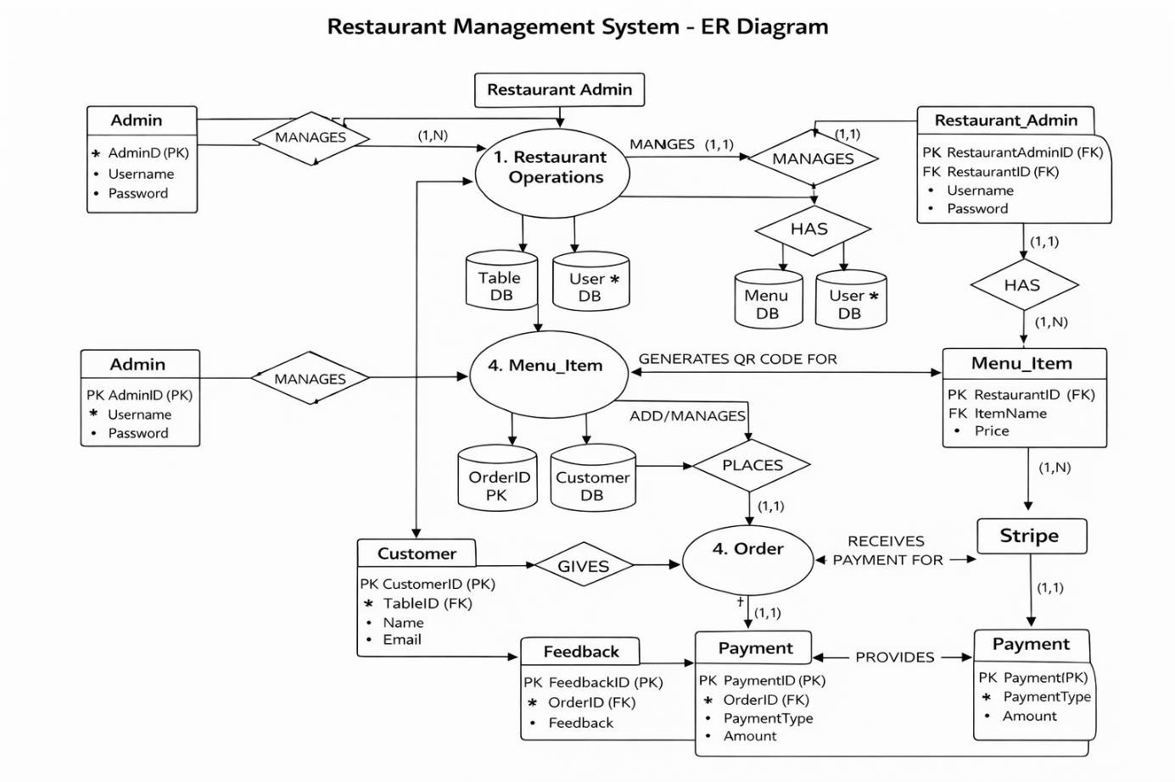
New to add
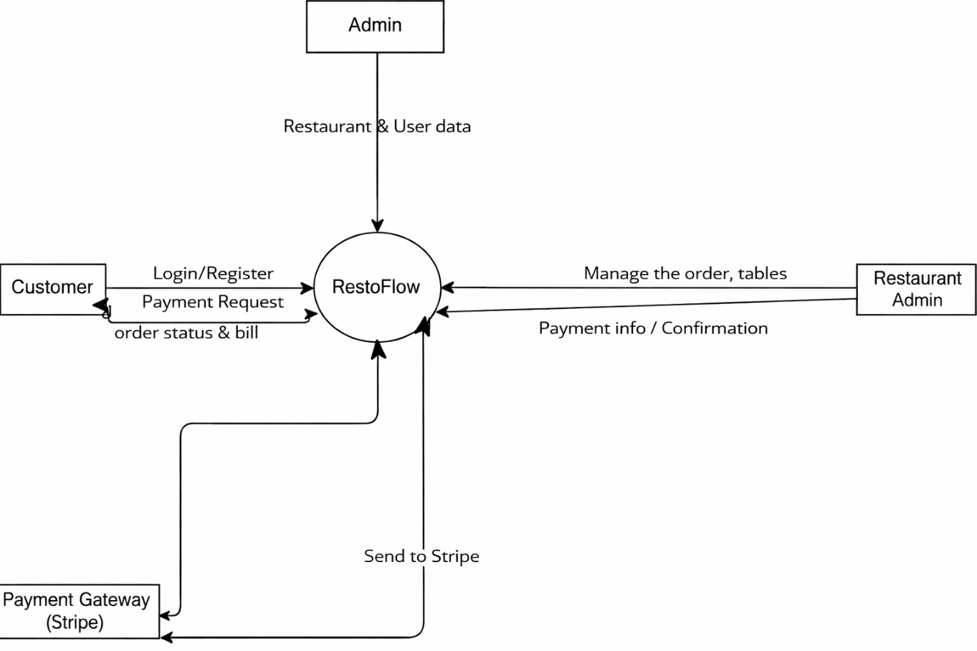
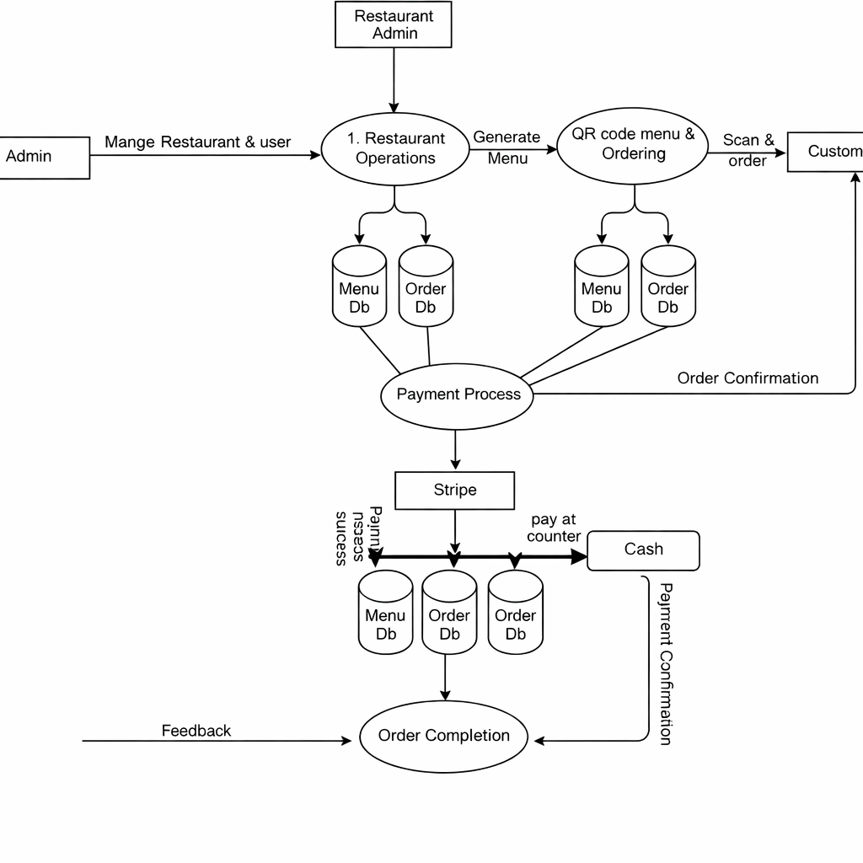
New Create
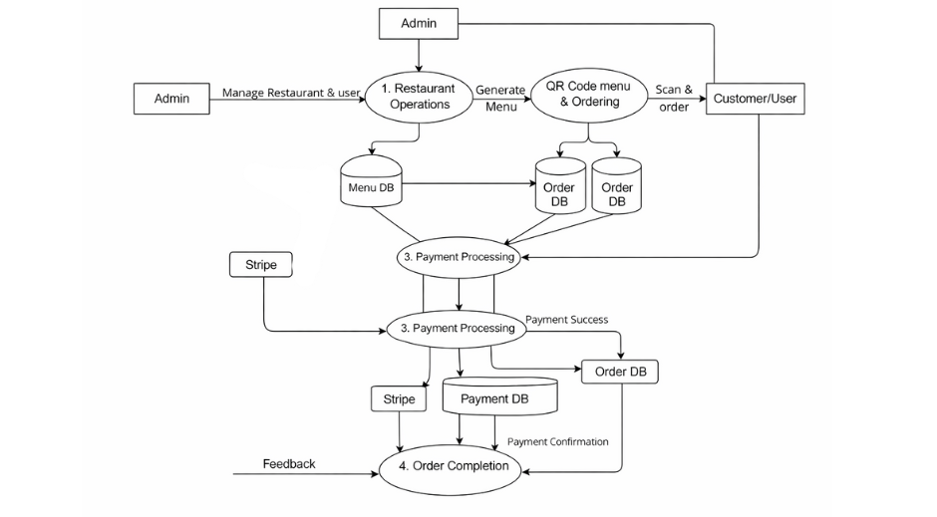

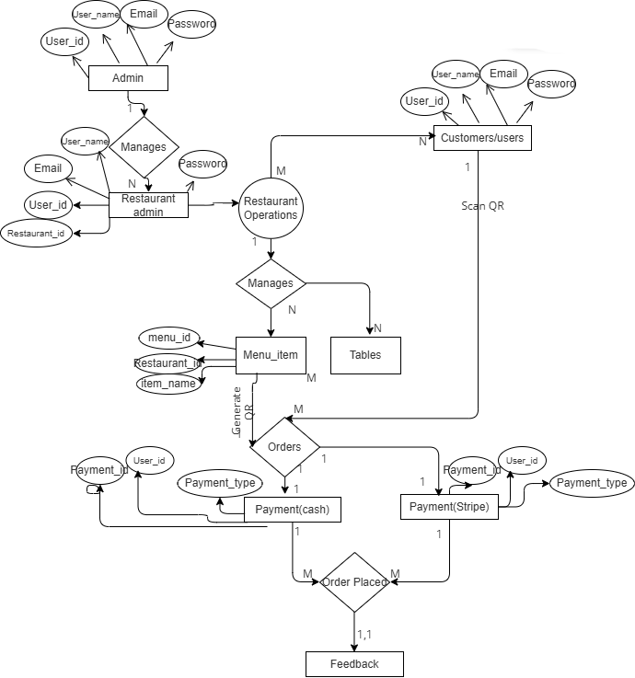

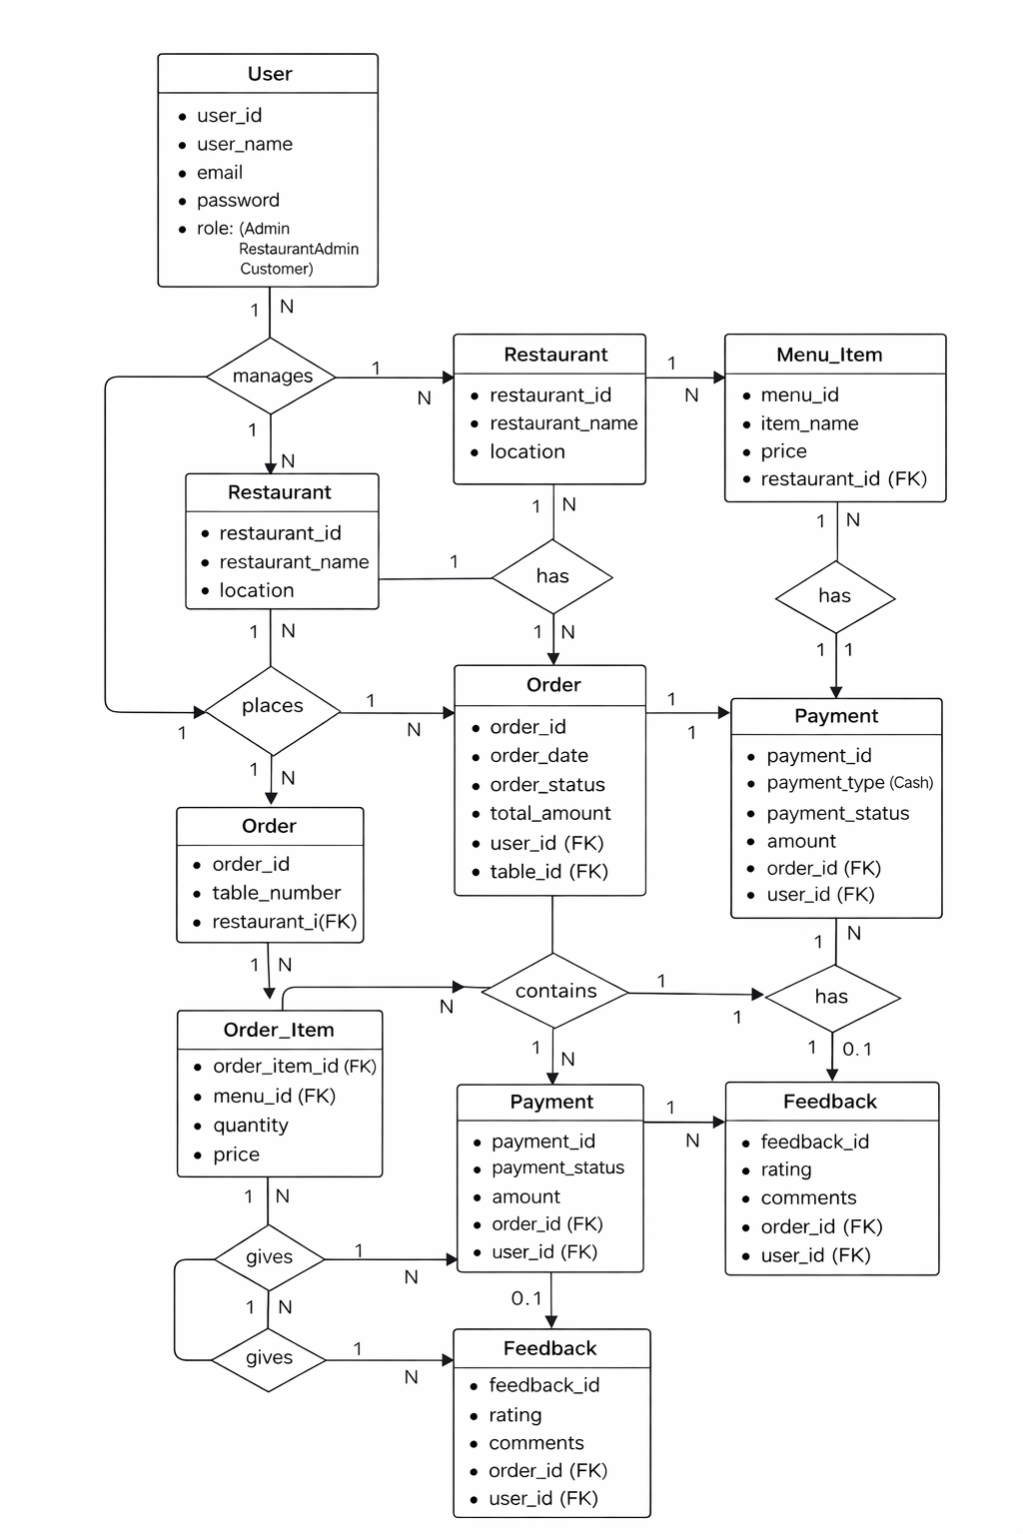

1. Technical Feasibility
The Restaurant Management System has been successfully developed using a modern and scalable technology stack (ASP.NET Core, SQL Server, React, Stripe, SignalR).
All core modules — authentication, restaurant management, reservations, orders, payments, analytics, and real-time updates — are fully implemented and production-ready.
The system is secure, scalable, and optimized for performance with proper database design, cloud deployment readiness, and secure payment integration.
Status: Technically Sound and Successfully Implemented

2. Legal Feasibility
The system complies with data protection and payment security standards.
- Secure authentication and encrypted data handling implemented
- Stripe ensures PCI-DSS compliant payment processing
- Privacy policy, terms of service, and refund policies defined
- Designed to support regulatory and tax compliance requirements
Status: Legally Compliant and Safe for Deployment

3. Operational Feasibility
The system effectively supports real-world restaurant operations.
- Customers can order and reserve tables easily
- Restaurant admins can manage menus, orders, payments, and analytics
- System admins can manage users and restaurants centrally
The workflow aligns with standard restaurant processes, and minimal training is required for staff.
Status: Operationally Practical and User-Friendly

4. Schedule (Time) Feasibility
The project has been completed within the planned timeline.
All development phases — implementation, testing, optimization, and deployment preparation — were successfully executed.
The system is now ready for full-scale production use and future scalability.
Status: Completed Within Planned Timeframe
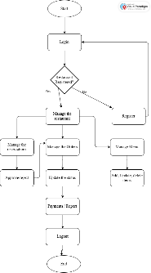
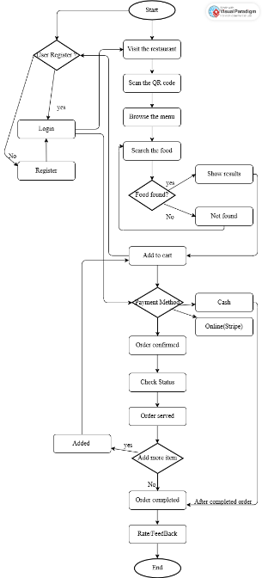
Data Dictionary
1. Users Table
Description: Stores all the user related details in this. Role based storage of data.
Sr No | Field Name | Datatype | Constraints | Description
1 | UserId | int | Unique Identifier, Primary Key | Unique ID for all user
2 | FullName | varchar | Not Null | Name of the user
3 | Email | varchar | Not Null, Unique | Email of the user
4 | PasswordHash | varchar | Not Null | Hashed password for the authentication
5 | UserType | varchar | Not Null | Specific user: i.e Admin, Restaurant Admin, Customer
6 | RestaurantId | int | Allow nulls | References from Restaurant
7 | PhoneNumber | varchar | Allow nulls | Number of the user
8 | CreatedAt | datetime | Auto-generated | Timestamp when user was created
9 | OTP | nvarchar | Allow Null, Auto-generated | Generated when login

2. Restaurant
Description: Have all the information related to the restaurant.
Sr No | Field Name | Datatype | Constraints | Description
1 | RestaurantId | int | Unique, Primary Key | Unique for all the restaurants
2 | Name | varchar | Not Null | Restaurant Name
3 | Address | varchar | Allow null | Restaurant Address
4 | Phone | varchar | Allow null | Restaurant Phone Number
5 | OpenTime | time | Allow null | Opening time
6 | CloseTime | time | Allow null | Closing time
7 | IsActive | bit | Not null, Default: 1 | Active status  1: active 0: close
8 | CreatedAt | datetime | Auto-generated | Created Timestamp

3. Tables
Description: All the table related things. Adding table connected with restaurantid with different tableid.
Sr No | Field Name | Datatype | Constraints | Description
1 | TableId | int | Unique, Primary Key | Unique for all the Tables
2 | RestaurantId | int | Not null | Reference from restaurant table
3 | TableNumber | varchar | Not null | Give tables a no. ex: 1,2,3
4 | Capacity | int | Not null | For how many persons’ table
5 | Status | varchar | Not null,  Default:‘Available’ | Check status of the table  Check constraints ('Available', 'Occupied', 'Reserved')
6 | QRCodeUrl | varchar | Not null | Set QR on the table
7 | CreatedAt | datetime | Auto-generated | Created Timestamp

4. Meals
Description: All the meal related things are here stored with restaurantid with different mealid.
Sr No | Field Name | Datatype | Constraints | Description
1 | MealId | int | Unique, Primary Key | Unique for all the Meals
2 | RestaurantId | int | Not null, FK | Reference from the restaurant table
3 | Name | varchar | Not null | Meal name
4 | Description | varchar | Allow null | Items description
5 | Price | decimal | Not null | Items price
6 | Category | varchar | Allow null | Items category wise
7 | ImageUrl | varchar | Allow null | Items image
8 | IsAvailable | bit | Allow null,  Default: (1) | Check availability
9 | IsBestItem | bit | Allow null,  Default: (0) | For best item
10 | CreatedAt | datetime | Auto-generated | Created Timestamp

5. QRCode
Description: Set the QR code with the table id to exactly get order from that table.
Sr No | Field Name | Datatype | Constraints | Description
1 | QRCodeId | int | Unique, Primary Key | Unique for all the Qrcode
2 | TableId | int | Not null, FK | Reference from the tables’ table
3 | QRCodeImageUrl | varchar | Allow null | Set the QR code image
4 | CreatedAt | datetime | Auto-generated | Created Timestamp

6. Orders
Description: With unique order id all the orders are stored here.
Sr No | Field Name | Datatype | Constraints | Description
1 | OrderId | int | Unique, Primary Key | Unique for all the Orders
2 | RestaurantId | int | Not null, FK | References from Restaurant table
3 | TableId | int | Not null, FK | References from tables’ table
4 | CustomerId | int | Not null, FK | References from User table
5 | OrderStatus | varchar | Not null,  Default:(Pending) | For the checking the order status  ('Pending','Preparing','Served','Completed','Cancelled')
6 | TotalAmount | decimal | Allow null,  Default: 0 | Total value of order
7 | CreatedAt | datetime | Auto-generated | Created Timestamp
8 | PaymentStatus | varchar | Allow null,  Default: Pending | For the checking the payment status  ('Pending','Paid','Failed','Refunded')

7. OrderItems
Description: Order Items with total quality and amount are stored here.
Sr No | Field Name | Datatype | Constraints | Description
1 | OrderItemId | int | Unique, Primary Key | Unique for all the OrderItems
2 | OrderId | int | Not null | Reference from order table
3 | MealId | int | Not null | Reference from meal table
4 | Quantity | int | Not null | Add the quality of the item
5 | Price | decimal | Not null | Price of item
6 | TotalPrice | decimal | Allow null | Total price of item

8. Payments
Description: After ordering the payment status related and paid payment with unique transaction is shown here.
Sr No | Field Name | Datatype | Constraints | Description
1 | PaymentId | int | Unique, Primary Key | Unique for all the Payments
2 | OrderId | int | Not null | Reference from order table
3 | Amount | decimal | Not null | Amount to pay
4 | PaymentMode | varchar | Not null | In which mode to pay
5 | PaymentStatus | varchar | Not null,  Default: Pending | Check the payment status
6 | TransactionId | varchar | Allow null | Get the transaction id of the payment
7 | CreatedAt | datetime | Auto-generated | Created Timestamp

9. SavedPaymentMethod
Description: The online card details are stored here that can use other time.
Sr No | Field Name | Datatype | Constraints | Description
1 | SavedPaymentMethodId | int | Unique, Primary Key | Unique for all the Payment
2 | CustomerId | int | Not null, FK | References from the User
3 | StripePaymentMethodId | nvarchar | Not null | Unique Id for all payment method
4 | CardBrand | nvarchar | Not null | Enter the card brand
5 | Last4 | nvarchar | Not null | Saved the last 4 digit of card
6 | ExpMonth | nvarchar | Allow null | Saved the exp month of card
7 | ExpYear | nvarchar | Allow null | Saved the exp year of card
8 | CreatedAt | datetime | Auto-generated | Created Timestamp
9 | LastUsedAt | datetime | Datetime | Put the last date
10 | IsDefault | bit | Allow null,  Default: 0

10. Reviews
Description: After order and payment completion the last step to give the review on the item to the restaurant.
Sr No | Field Name | Datatype | Constraints | Description
1 | ReviewId | Int | Unique, Primary Key | Unique for all the Reviews
2 | RestaurantId | Int | Not null, FK | References from restaurant table
3 | CustomerId | Int | Not null, FK | References from user table
4 | Rating | Int | Not null,  Check from 1 to 5 | Give the rating as on star
5 | Comment | varchar | Allow null | Give the comment
6 | CreatedAt | datetime | Auto-generated | Created Timestamp

11. Reservations
Description: To do reservation in the restaurant than the details need to fill and it is stored here.
Sr No | Field Name | Datatype | Constraints | Description
1 | ReservationId | int | Unique, Primary Key | Unique for all the Reservations
2 | RestaurantId | int | Not null, FK | Reference from restaurant
3 | TableId | int | Not null, FK | Reference from tables’ table
4 | CustomerId | int | Not null, FK | Reference from user table
5 | ReservationDate | date | Not null | Set the date
6 | ReservationTime | time | Not null | Set the time
7 | Duration | int | Not null,  Default: 60 min | Duration to have
8 | NumberOfGuests | int | Not null | Add no of guest to come
9 | Status | nvarchar | Not null,  Default: Pending | See the status of order  ('Pending','Approved','Rejected','Cancelled','Completed')
10 | SuggestedTime | time | Allow null | Give the time back to customer
11 | Notes | nvarchar | Allow null | Add note to manager or restaurant
12 | AdminNotes | nvarchar | Allow null | Give notes to customer by restaurant
13 | CustomerPhone | nvarchar | Not null | To give the phone number
14 | CustomerName | nvarchar | Not null | To give the name
15 | CreatedAt | datetime | Auto-generated | Created timestamp
16 | UpdatedAt | datetime | Auto-generated | Created timestamp

Test Cases :
1. Registration ( Admin, RestaurantAdmin, Customer)
Sr No | Field | Test Data (input) | Expected Output | Actual Output | Result
1 | Full Name* | Null | Full name is required | Username is Required | Failed to register
1 | Full Name* | 1234 | Enter alphabet only | Username is Required | Failes to register
1 | Full Name* | Himanshu Ladha | Register successful | Register successful | Register Success
2 | Email* | Null | Email is required | Email is required | Failed to register
2 | Email* | *^@gmail.com | Invalid email | Invalid email | Failed to register
2 | Email* | himanshu@.com | Invalid email | Invalid email | Failed to register
2 | Email* | Himanshuladha8@gmail.com | Valid email | Valid email | Register Successful
3 | Password* | Null | Password is required | Password is required | Failed to register
3 | Password* | him@1 | Invalid Password | Password must be 6 char long | Failed to register
3 | Password* | him@123 | Valid Password | Register successfully | Register success
4 | Phone number* | Null | Number is required | Number is required | Failed to register
4 | Phone number* | 123456789 | Invalid Number | Number should be of 10 digit | Failed to register
4 | Phone number* | 1234567890 | Register Successfully | Register Successfully | Register Success
5 | Role | Admin | Register Successfully | Register Successfully | Register Success
5 | Role | Restaurant Admin | Register Successfully | Register Successfully | Register Success
Note : * field also used for Customer as well.
2. Login (Admin, RestaurantAdmin, Customer)
Sr No | Field | Test data | Expected Output | Actual Output | Result
1 | Email | Null | Email is required | Email is required | Failed to Login
1 | Email | *^@gmail.com | Invalid email | Invalid email | Failed to Login
1 | Email | himanshu@.com | Invalid email | Invalid email | Failed to Login
1 | Email | Himanshuladha876@gmail.com | Email doesn’t match | Invalid email | Failed to Login
1 | Email | himanshuladha8@gmail.com | Valid email | Valid email | Login Success
2 | Password | Null | Password is required | Password is required | Failed to login
2 | Password | him@1 | Invalid Password | Password must be 6 char long | Failed to login
2 | Password | him@12 | Valid Password | Valid Password | Login Success
3 | OTP | Null | OTP is required | OTP is required | Failed to login
3 | OTP | 1234 | Invalid OTP | Invalid OTP | Failed to login
3 | OTP | 1222 | Valid OTP | Valid OTP | Login Success
Note : Login field is same for Admin, RestaurantAdmin, Customer
3. Forgot Password
Sr no | Field | Test Data | Expected Output | Actual Output | Result
1 | Email | Null | Email is required | Email is required | Failed to Login
1 | Email | *^@gmail.com | Invalid email | Invalid email | Failed to Login
1 | Email | himanshu@.com | Invalid email | Invalid email | Failed to Login
1 | Email | Himanshuladha876@gmail.com | Email doesn’t match | Invalid email | Failed to Login
1 | Email | himanshuladha8@gmail.com | Valid email | Valid email | Login Success
2 | New Password | Null | Password is required | Password is required | Failed to change
2 | New Password | him@1 | Invalid Password | Password must be 6 char long | Failed to Change
2 | New Password | him@12 | Valid Password | Valid Password | Enter the New password
3 | Confirm New Password | Null | Password is required | Password is required | Failed to Change
3 | Confirm New Password | him@1 | Invalid Password | Password should be same | Failed to Change
3 | Confirm New Password | him@12 | Valid Password | Valid Password | Password changed successfully

